**Introduction:**

China Town Restaurant's (Fictitious Restaurant Name) Reservation Page is designed to allow customers to book a table at the restaurant for a specific date and time. This documentation will guide you through the process of using the form and provide any special features or considerations that the restaurant's management team should be aware of.

**How to use the form:**

1. Select the date you would like to reserve a table for from the "Select Date" input field.
2. Select the time you would like to reserve a table for from the "Select Time" input field.
3. Enter the number of guests that will be attending in the "Number of Guests" input field. The minimum number of guests that can be entered is 1.
4. Enter your contact information in the "Contact Information" input field. This includes your phone number, which should be a 10-digit number.
5. Click the "Submit Information" button to submit your reservation request.

**Special Features and Considerations:**

* The form has several required input fields, which are denoted by the "required" attribute in the HTML code. These fields must be filled out in order to submit the form.
* The "Number of Guests" input field has a minimum value of 1, meaning that at least one guest must be present in order to make a reservation.
* The "Contact Information" input field is a telephone number field, meaning that only numbers can be entered. Additionally, the "minlength" and "maxlength" attributes are set to 10, meaning that the phone number entered must be 10 digits long.
* The form's background is a gradient that uses the restaurant's colors to create a cohesive look and feel.
* The webpage is completely responsive and adjusts according to the resolution on which it is opened (Due to Bootstrap Grid System).

**Example:**

To reserve a table for 4 guests on August 15th at 7:30 pm, follow these steps:

1. Select "August 15th, 2023" from the "Select Date" input field.

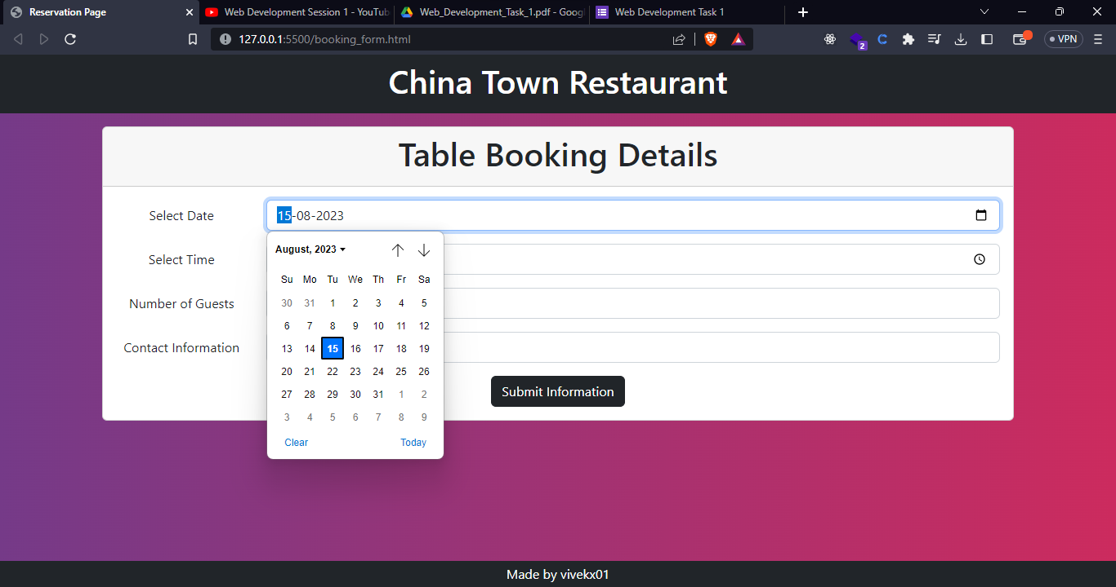

1. Select "7:30 pm (19:30)" from the "Select Time" input field.

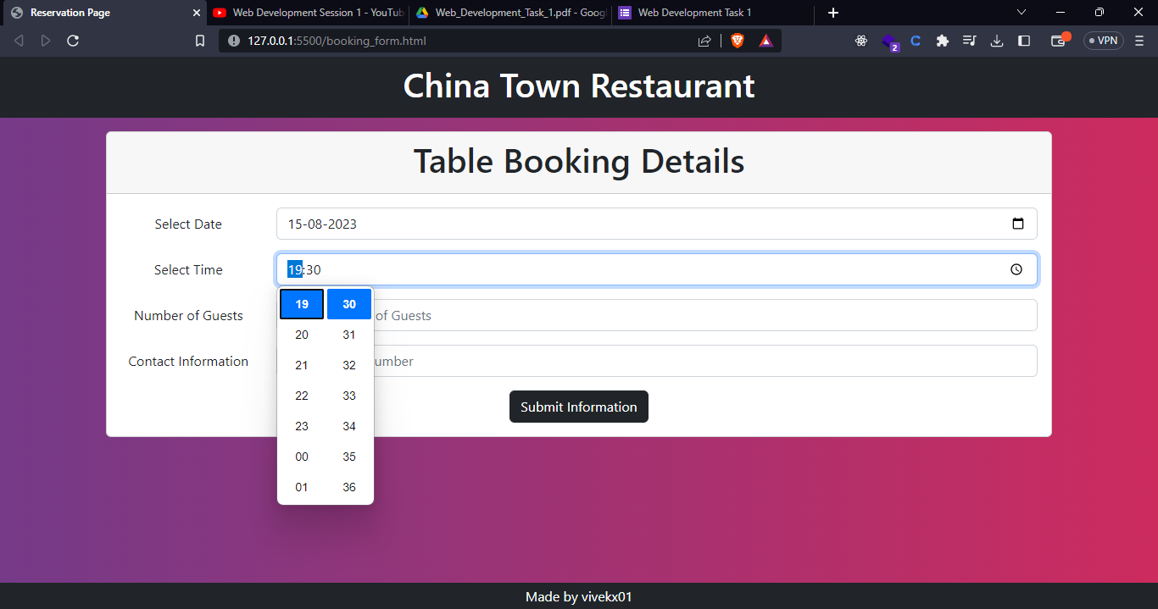

1. Enter "4" in the "Number of Guests" input field.

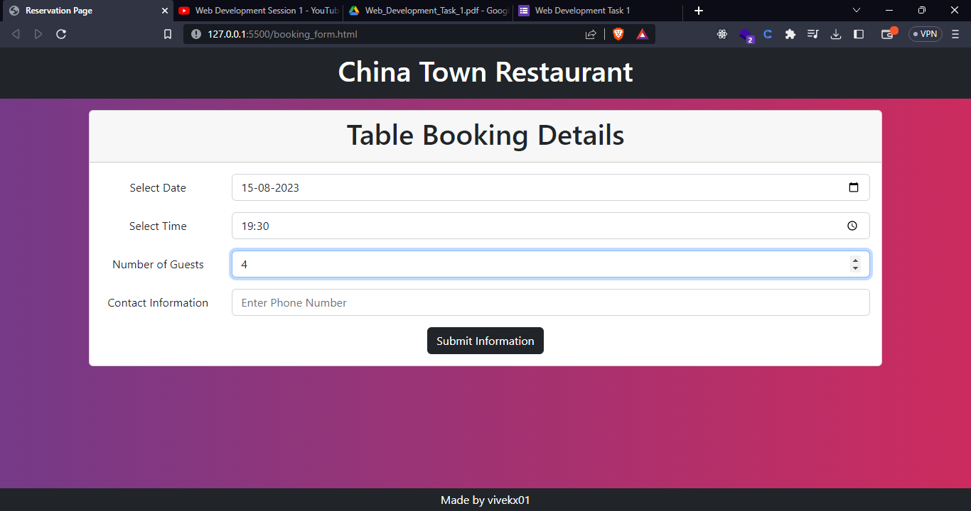

1. Enter your 10-digit phone number in the "Contact Information" input field.

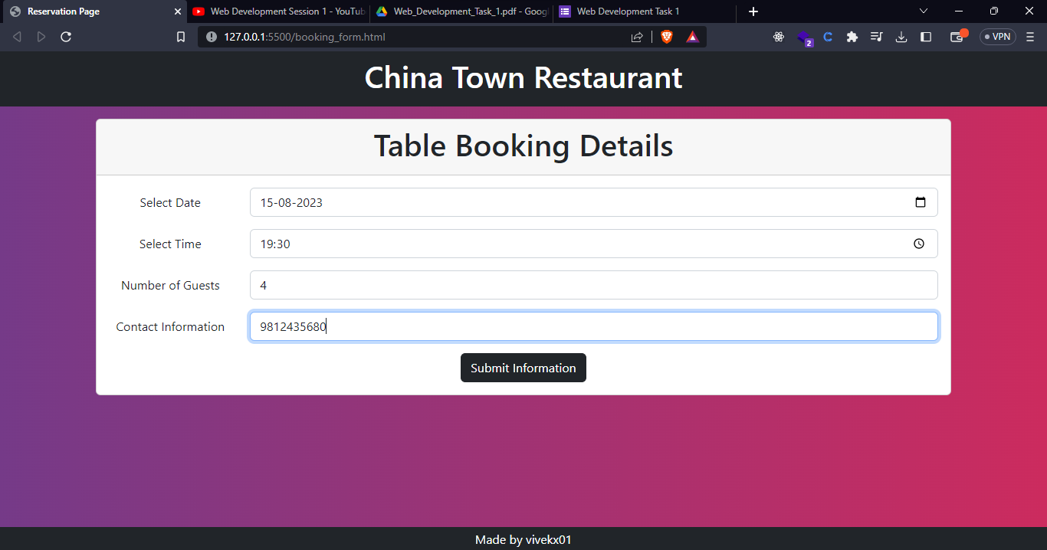

1. Click the "Submit Information" button to submit your reservation request.

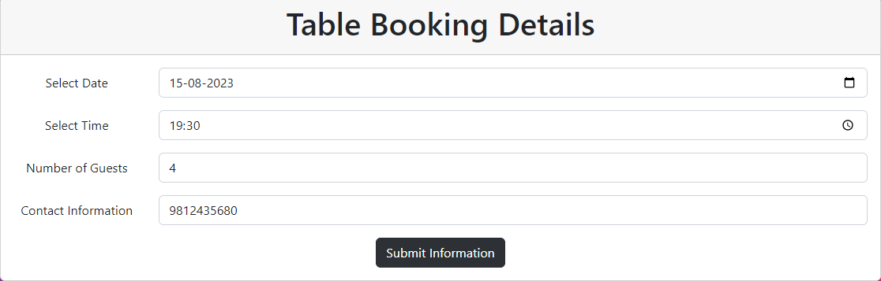

**Source Code:**

<!doctype html>

<html lang="en">

  <head>

    <meta charset="utf-8">

    <meta name="viewport" content="width=device-width, initial-scale=1">

    <title>Reservation Page</title>

    <link href="https://cdn.jsdelivr.net/npm/bootstrap@5.2.3/dist/css/bootstrap.min.css" rel="stylesheet" integrity="sha384-rbsA2VBKQhggwzxH7pPCaAqO46MgnOM80zW1RWuH61DGLwZJEdK2Kadq2F9CUG65" crossorigin="anonymous">

  </head>

  <style>

    body{

    background: #cc2b5e;  /* fallback for old browsers */

    background: -webkit-linear-gradient(to right, #753a88, #cc2b5e);  /* Chrome 10-25, Safari 5.1-6 */

    background: linear-gradient(to right, #753a88, #cc2b5e); /* W3C, IE 10+/ Edge, Firefox 16+, Chrome 26+, Opera 12+, Safari 7+ */

  }

  </style>

  <body>

    <header class="bg-dark py-2">

        <h1 class="text-center text-white">China Town Restaurant</h1>

    </header>

    <div class="container mt-3">

        <div class="card">

            <div class="card-header text-center">

                <h1>Table Booking Details</h1>

            </div>

            <div class="card-body text-center">

               <form action="">

                <div class="mb-3 row">

                    <label for="staticEmail" class="col-sm-2 col-form-label">Select Date</label>

                    <div class="col-sm-10">

                      <input type="date" class="form-control" required>

                    </div>

                  </div>

                  <div class="mb-3 row">

                    <label for="inputPassword" class="col-sm-2 col-form-label">Select Time</label>

                    <div class="col-sm-10">

                      <input type="time" class="form-control" required>

                    </div>

                  </div>

                  <div class="mb-3 row">

                    <label for="inputPassword" class="col-sm-2 col-form-label">Number of Guests</label>

                    <div class="col-sm-10">

                      <input type="number" placeholder="Enter Number of Guests" min="1" class="form-control" required>

                    </div>

                  </div>

                  <div class="mb-3 row">

                    <label for="inputPassword" class="col-sm-2 col-form-label">Contact Information</label>

                    <div class="col-sm-10">

                      <input type="tel" placeholder="Enter Phone Number" class="form-control" minlength="10" maxlength="10" required>

                    </div>

                  </div>

                  <button type="submit" class="btn btn-dark button">Submit Information</button>

               </form>

            </div>

        </div>

    </div>

    <footer class="fixed-bottom text-center text-white bg-dark py-1">

        Made by vivekx01

    </footer>

    <script src="https://cdn.jsdelivr.net/npm/bootstrap@5.2.3/dist/js/bootstrap.bundle.min.js" integrity="sha384-kenU1KFdBIe4zVF0s0G1M5b4hcpxyD9F7jL+jjXkk+Q2h455rYXK/7HAuoJl+0I4" crossorigin="anonymous"></script>

  </body>

</html>